**無線通訊系統 HW2**

108064535 陳文遠

1. **Consider that an MS with a velocity v receives an unmodulated carrier with a frequency fc. The incidence angle theta(t) of the incoming wave is assumed to be uniformly distributed between –pi and pi.**
2. If v = 20 km/hr and fc = 2 GHz, find the distribution function (cdf) and the probability density function (pdf) of the observed Doppler shift via simulation.

<SOL> 隨機產生 100000 筆 (可調整筆數) Doppler frequency shift 的資料，接著統計這些資料中在各點的密度，並畫出 pdf 與 cdf 圖形

**Figure1. when v=20km/hr, fc=2GHz**

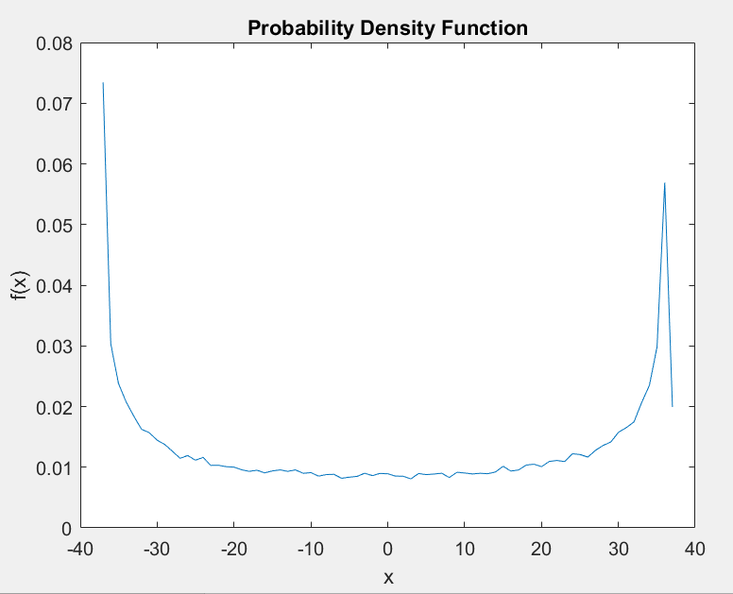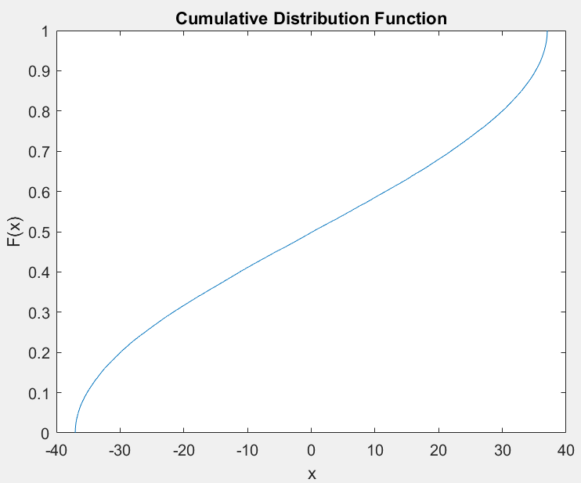

1. If v = 90 km/hr and fc = 26 GHz, find the cdf and the pdf of the observed Doppler shift via simulation.

<SOL> 做法與 (a) 小題相同，只是將 v 與 fc 的定值做修改而已，以下圖形分別為 pdf 與 cdf

**Figure2. When v=90km/hr, fc=26GHz**

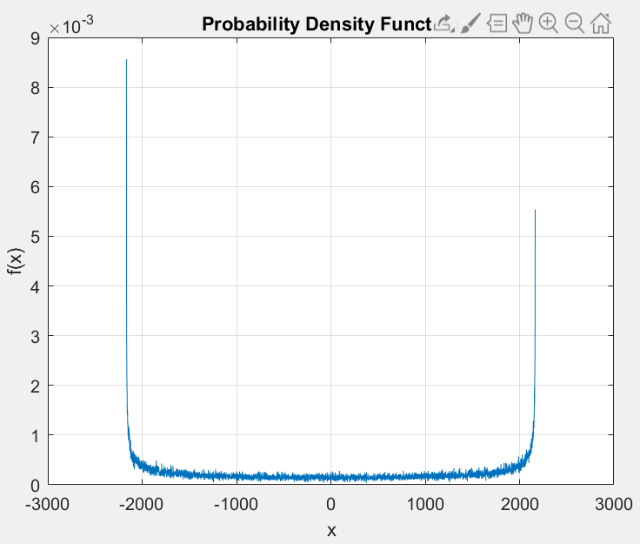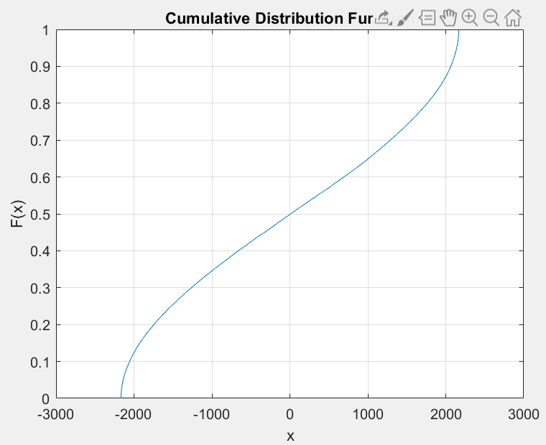

1. If fc = 2 GHz and v is uniformly distributed between 20 km/hr and 90 km/hr, find the cdf and the pdf of the observed Doppler shift via simulation.

<SOL> (c) 小題中的 v 也變成了隨機數，所以如果以 (a) 和 (b) 小題的方法來統計 pdf 的話會導致計算量過大，所以在此題中直接使用了 hist( ) 函數來統計出密度，它似乎會導致統計出來的數據比較不精確，但是運算速度很快，下圖為 pdf 與 cdf

**Figure3. When v=20km/hr ~ 90km/hr, fc=2GHz**

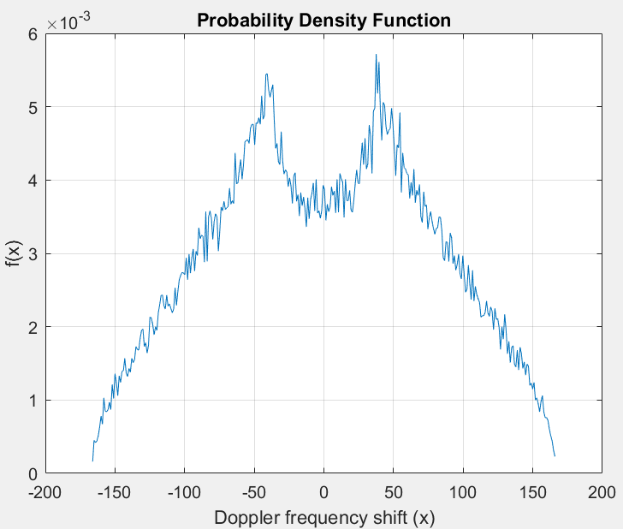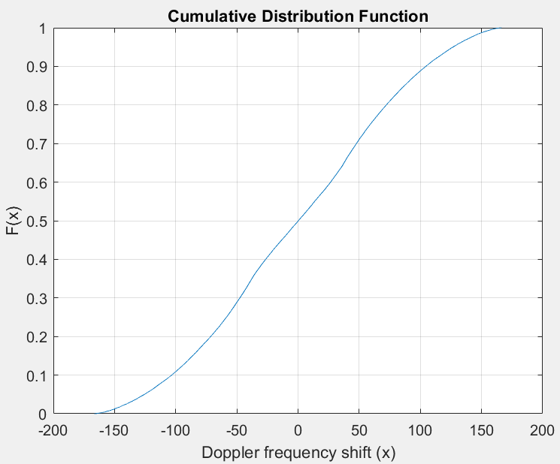

1. Derive the cdf and the pdf of the observed Doppler shift for fixed v and fc. Compare the simulation results with the theoretical results.

<SOL> 以下為以理論的角度所推導出來的 pdf 與 cdf 公式

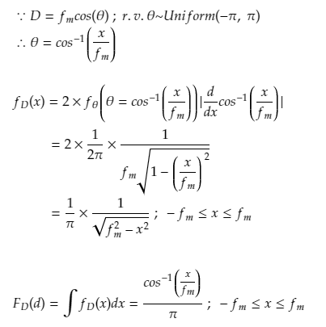

**Figure4. When v=20km/hr, fc=2GHz, using theoretical method**

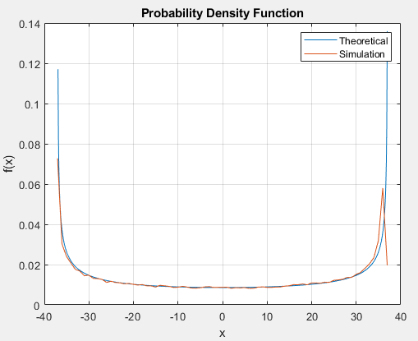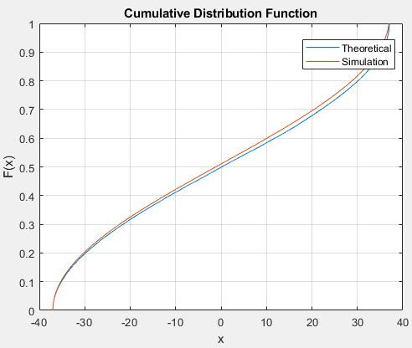

**Figure5. When v=90km/hr, fc=26GHz, using theoretical method**

